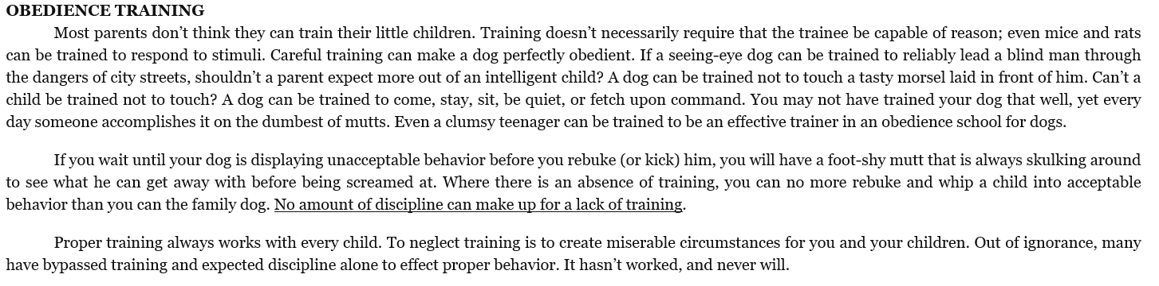

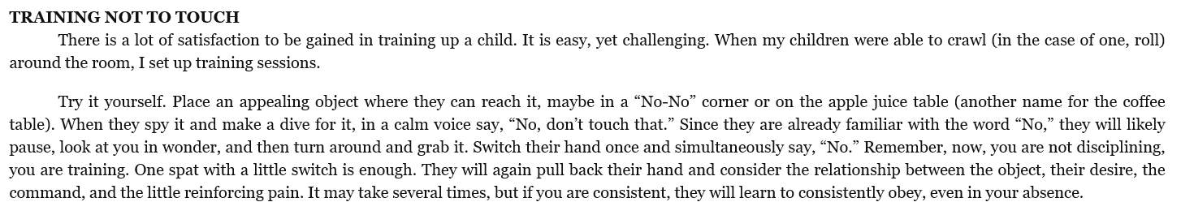



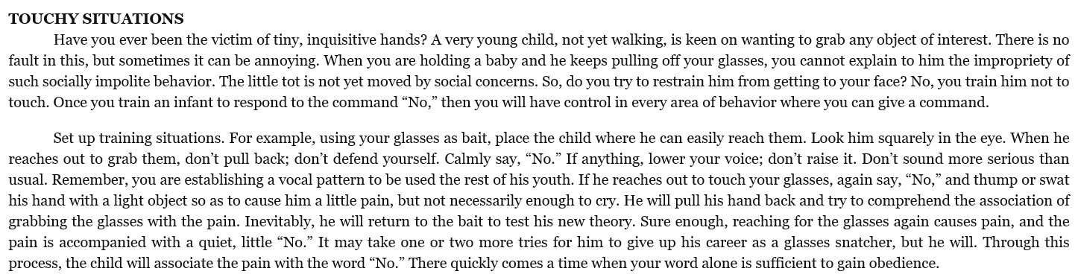

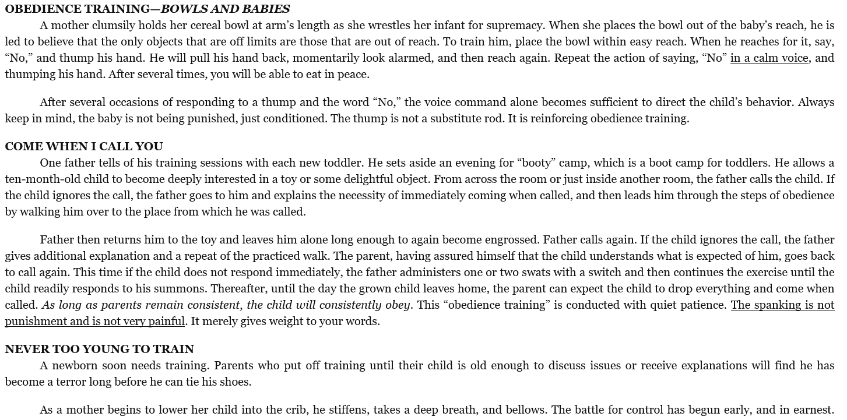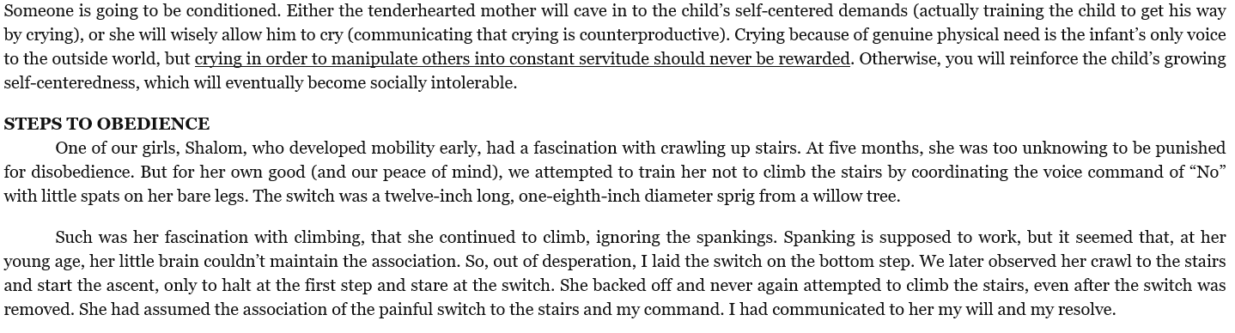

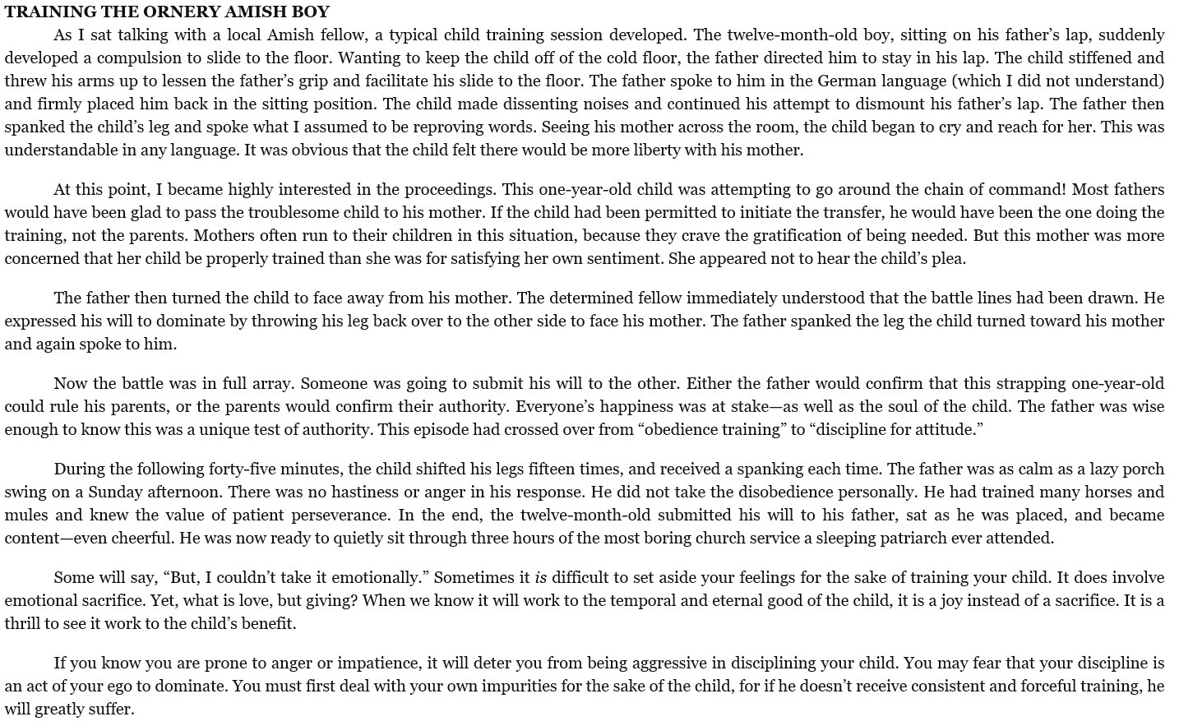

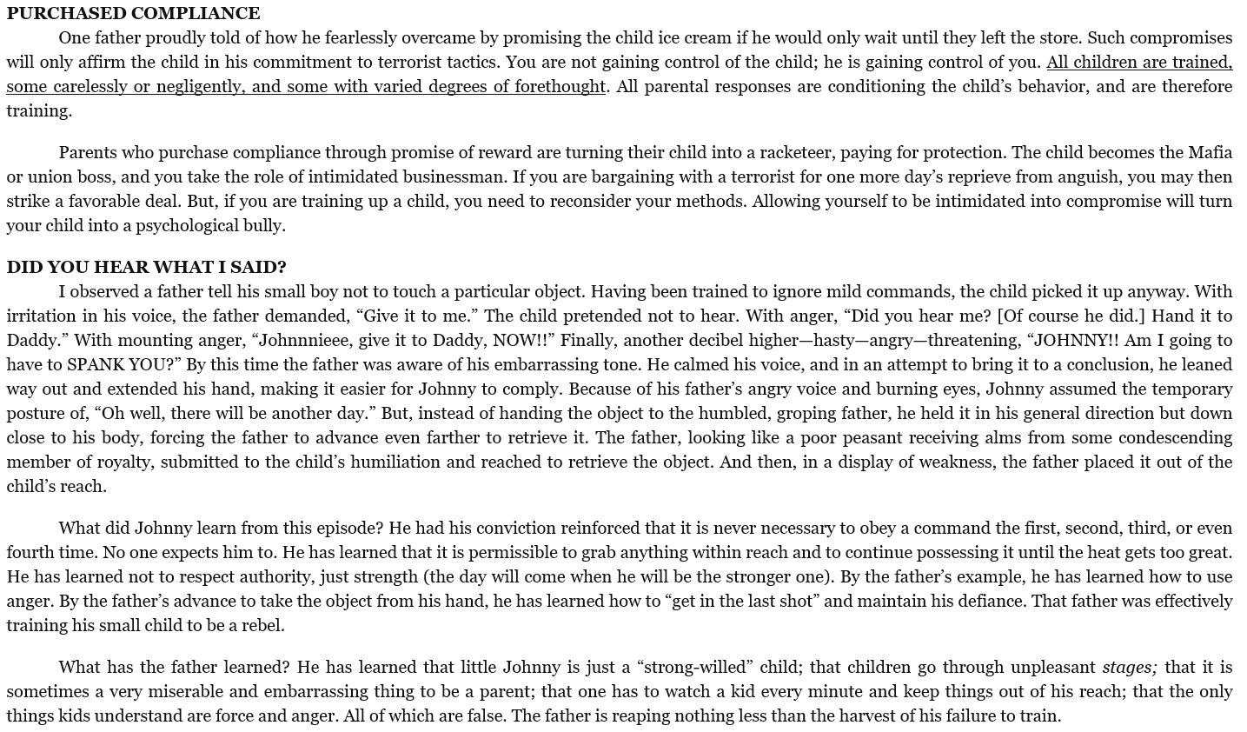

|  |  |
| --- | --- |
|  | The above material was excerpted from Chapter 1 of Michael and Debbie Pearl’s book, *To Train Up a Child*. |